

**DEPT. Of Computer Science Engineering**

**SRM IST, Ramapuram**

**Sub Code & Name: 18CSS201J - ANALOG AND DIGITAL ELECTRONICS**

|  |  |
| --- | --- |
| **Experiment No** | 01 |
| **Title of Experiment** | Design and Implementation of Half Wave and Full Wave Rectifiers using simulation package and demonstrate its working |
| **Name of the** | Bharathwaj.M |
| **Register Number** | RA2011026020065 |
| **Date of Experiment** |  |

**Mark Split Up**

|  |  |  |  |
| --- | --- | --- | --- |
| **S.No** | **Description** | **Maximum Mark** | **Mark Obtained** |
| 1 | Oral Viva / Online Quiz | 5 |  |
| 2 | Execution | 10 |  |
| 3 | Model Calculation / Result Analysis | 5 |  |
| **Total** | | **20** |  |

**Staff Signature with date**

**Aim**

To construct a Half wave and Full wave rectifier using diode and to draw its performance characteristics.

**Apparatus Required:**

|  |  |  |  |  |
| --- | --- | --- | --- | --- |
| S.No | Particulars | Type | Range | Quantity |
| 1 | Diode | 1N4001 |  | 4 |
| 2 | Resistor |  | 100 to 10000Ω | As per required |
| 3 | Capacitor |  | 470µF | 1 |
| 4 | AC voltage source |  | 4V, 50Hz | 1 |
| 5 | Voltage Measurement probe. |  |  | 2 |

**Software Required:**

<https://www.multisim.com/>

**1)a) Half wave rectifier**

**Theory**

The process of converting an alternating current into direct current is known as rectification. The unidirectional conduction property of semiconductor diodes (junction diodes) is used for rectification. Rectifiers are of two types: (a) Half wave rectifier and (b) Full wave rectifier.

In a half-wave rectifier circuit, during the positive half-cycle of the input, the diode is forward biased and conducts. Current flows through the load and a voltage is developed across it. During the negative half cycle, it is reverse bias and does not conduct. Therefore, in the negative half cycle of the supply, no current flows in the load resistor as no voltage appears across it. Thus the dc voltage across the load is sinusoidal for the first half cycle only and a pure a.c. input signal is converted into a unidirectional pulsating output signal.

Another type of circuit that produces the same output as a full-wave rectifier is that of the Bridge Rectifier. This type of single-phase rectifier uses 4 individual rectifying diodes connected in a "bridged" configuration to produce the desired output but does not require a special center tapped transformer, thereby reducing its size and cost. The single secondary winding is connected to one side of the diode bridge network and the load to the other side. The 4 diodes labeled D arranged in "series pairs" with only two diodes conducting current during each half cycle. During the positive half cycle of the supply, diodes D1 and D2 conduct in se D3 and D4 are reverse biased and the current flows through the load as shown below . During the negative half cycle of the supply, diodes D3 and D4 conduct in series, but diodes D1 and D2 switch of as they are now reverse biased. The current flowing through the load is the same direction as before.

**Formula:**

Half wave rectifier without filter:

1. ; Vm = Peak voltage magnitude
2. Ripple factor =
3. % Efficiency =

Half wave rectifier with filter:

1. ; Vrpp = Peak to peak voltage magnitude
2. Ripple factor =

**Procedure:**

Without Filter

1. Give the connections as per the circuit diagram.
2. Give 6 V, 50Hz Input to the circuit.
3. Measure the rectifier output across the Load and input voltage.
4. Plot its performance graph.

With Filter

1. Give the connections as per the circuit diagram.
2. Give 6 V, 50Hz Input to the circuit.
3. Connect the Capacitor across the load.
4. Measure the rectifier output across the different load and input voltage
5. Plot its performance graph.

Circuit Diagram:

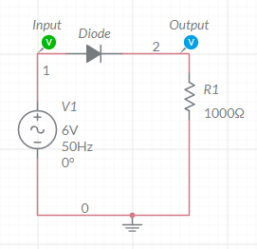 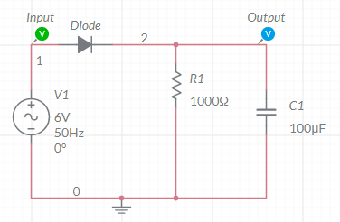

Half wave Rectifier – Without filter Half wave Rectifier – With filter

Model graph for half wave rectifier

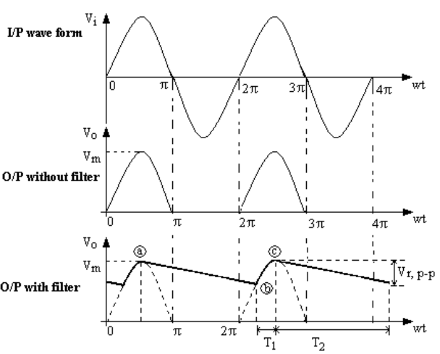

Tabulation

Without Filter

|  |  |  |  |  |
| --- | --- | --- | --- | --- |
| Vm (V) | Vrms (V) | Vdc (V) | Ripple Factor | Efficiency (%) |
| 6 | 3 | 1.909 | 1.212 | 40.4 |

With filter

|  |  |  |  |  |
| --- | --- | --- | --- | --- |
| Load Resistor | Vrpp (V) | Vrms (V) | Vdc (V) | Ripple factor |
| 10 Ω | 5.165 | 1.491 | 3.417 | 0.436 |
| 25 Ω | 5.177 | 1.494 | 3.411 | 0.437 |
| 50Ω | 4.915 | 1.418 | 3.542 | 0.400 |
| 100Ω | 4.059 | 1.171 | 3.970 | 0.294 |
| 1000Ω | 0.854 | 0.246 | 5.572 | 0.044 |

Model Calculation

Without filter

**Vm=6**

**Vrms=6/2=3**

**Vdc=6/**π =1.909

Ripple factor = =1.212

% Efficiency = =40.4

With filter:

For 10 ohms:  
Vrpp=5.165

Vrms=

Vdc=6-(5.165/2)=3.417

Ripple factor=1.491/3.417=0.436

Similarly done for the rest.

**Simulation waveform for without filter:**

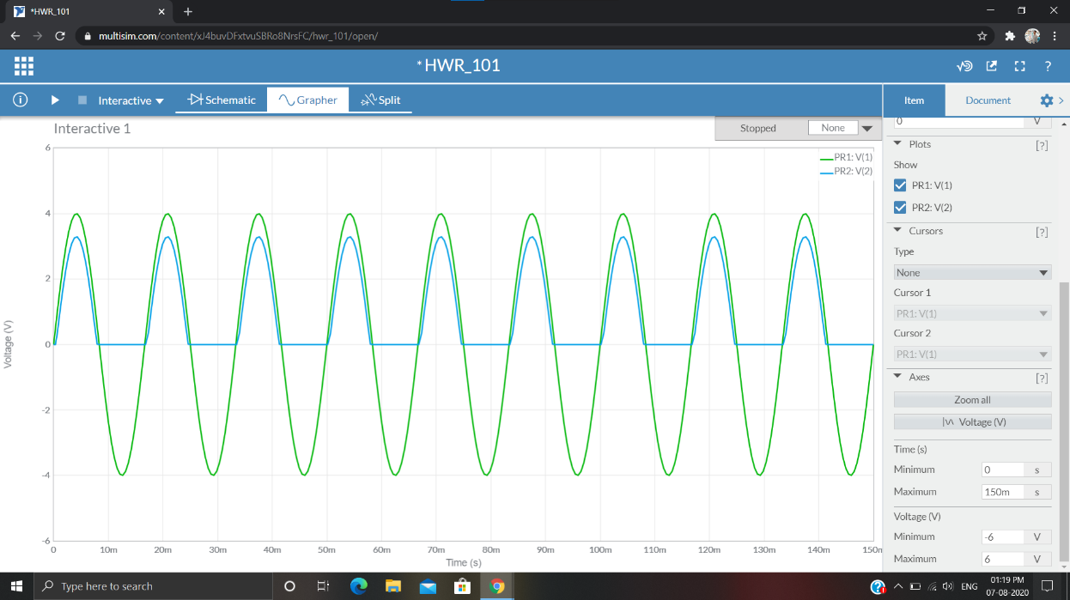

**Simulation waveform for with filter:**

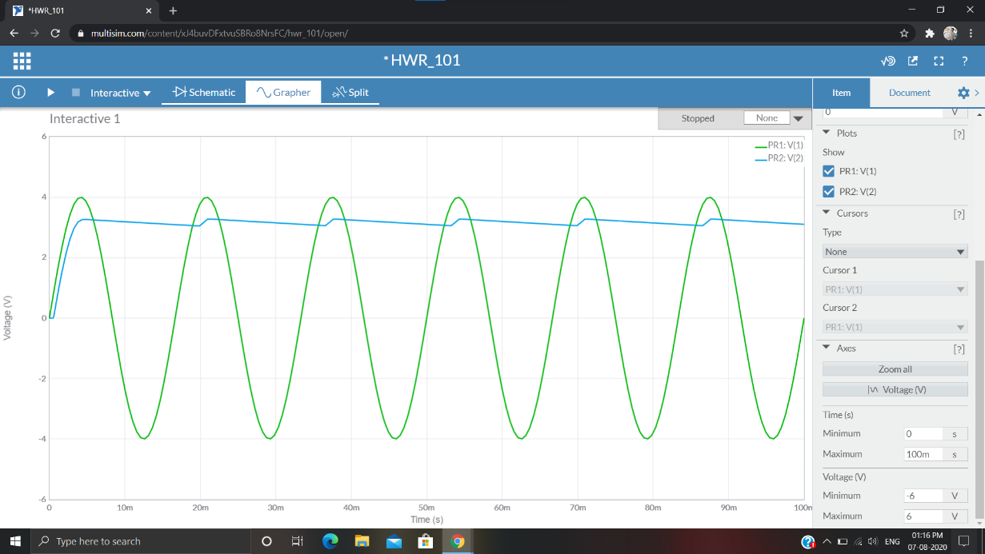

**Full wave rectifier**

**Theory**

Another type of circuit that produces the same output as a full-wave rectifier is that of the Bridge Rectifier. This type of single-phase rectifier uses 4 individual rectifying diodes connected in a "bridged" configuration to produce the desired output but does not require a special center tapped transformer, thereby reducing its size and cost. The single secondary winding is connected to one side of the diode bridge network and the load to the other side. The 4 diodes labeled D arranged in "series pairs" with only two diodes conducting current during each half cycle. During the positive half cycle of the supply, diodes D1 and D2 conduct in se D3 and D4 are reverse biased and the current flows through the load as shown below . During the negative half cycle of the supply, diodes D3 and D4 conduct in series, but diodes D1 and D2 switch of as they are now reverse biased. The current flowing through the load is the same direction as before.

**Model Graph:**

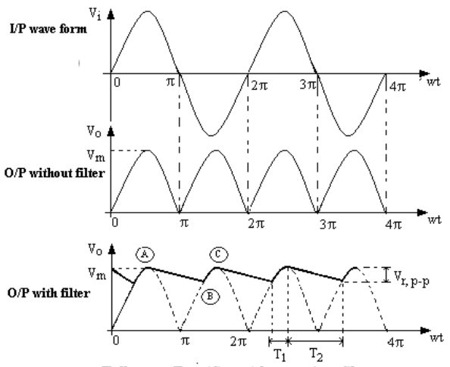

**FORMULA:**

Full wave rectifier without filter:

1. ; Vm = Peak voltage magnitude
2. Ripple factor =
3. % Efficiency =

Full wave rectifier with filter:

1. ; Vrpp = Peak to peak voltage magnitude
2. Ripple factor =

Procedure:

Without Filter

1. Give the connections as per the circuit diagram.
2. Give 6 V, 50Hz Input to the circuit.
3. Measure the rectifier output across the Load and input voltage.
4. Plot its performance graph.

With Filter

1. Give the connections as per the circuit diagram.
2. Give 6 V, 50Hz Input to the circuit.
3. Connect the Capacitor across the load.
4. Measure the rectifier output across the different Load and input voltage.
5. Plot its performance graph.

Circuit Diagram:

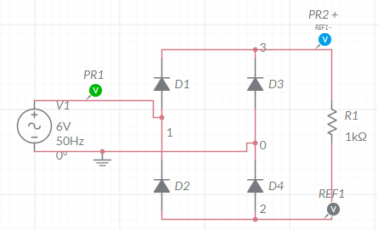

Full wave Rectifier – Without filter

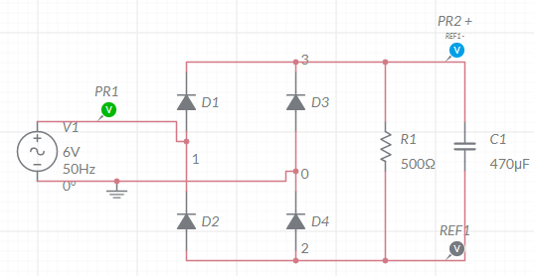

Full wave Rectifier – With filter

Tabulation

Without Filter

|  |  |  |  |  |
| --- | --- | --- | --- | --- |
| Vm (V) | Vrms (V) | Vdc (V) | Ripple Factor | Efficiency (%) |
| 6 | 4.242 | 3.819 | 0.483 | 81.05 |

With filter

|  |  |  |  |  |
| --- | --- | --- | --- | --- |
| Load Resistance | Vrpp (V) | Vrms (V) | Vdc (V) | Ripple factor |
| 10 Ω | 3.022 | 0.872 | 2.978 | 0.292 |
| 25 Ω | 1.874 | 0.540 | 4.126 | 0.131 |
| 50Ω | 1.167 | 0.336 | 4.833 | 0.069 |
| 100Ω | 0.5834 | 0.168 | 5.417 | 0.032 |
| 1000Ω | 0.076 | 0.022 | 5.924 | 0.003 |

Model Calculation:

Without Filter:

Vrms = 6/4.242

Vdc=(2x6)/=3.819

Ripple factor = =0.483

% Efficiency = =81.05

With Filter:

For 10 ohms,

Vrms=3.022/(2x)=0.872

Vrpp=3.022

Vdc=6-3.022=2.978

Ripple factor=0.872/2.978=0.292

Similarly for the rest.

**Simulation waveform for without filter:**

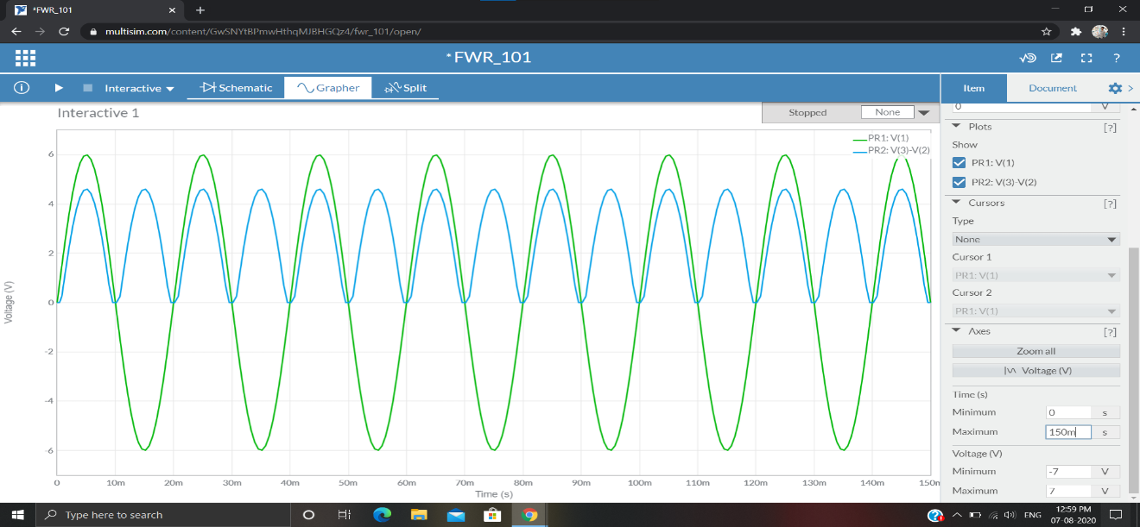

**Simulation waveform for with filter:**

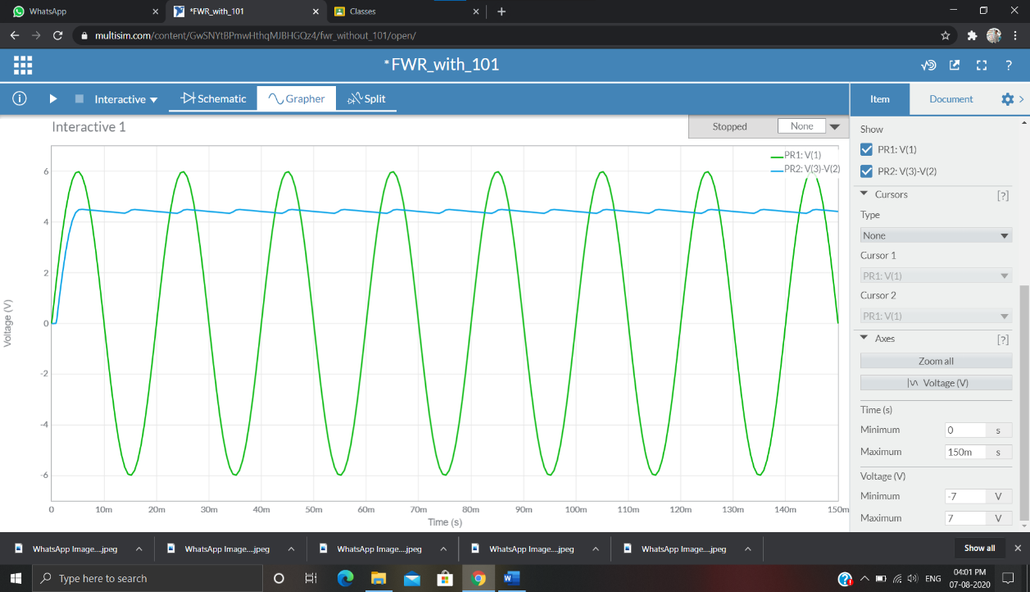

Result:

Thus, the performance characteristics of single phase Half wave and Full wave rectifier were obtained.